**Day 1 Activities**

Annotate the picture below to indicate which line of the for loop in the program is executed at which part of the pulse. You should show a total of 6 lines of code (lines 32-34 and lines 36-38). 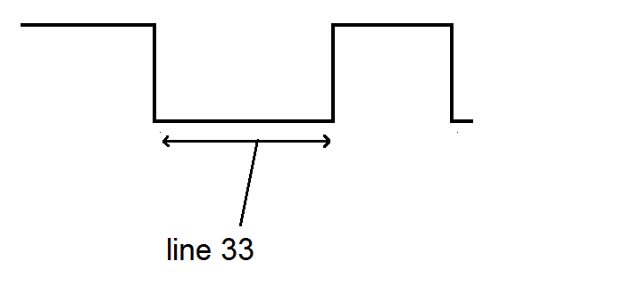

38

37

34, 36

32

33

|  |  |  |  |  |
| --- | --- | --- | --- | --- |
| Pulse | Duration (ms) | Timer A counts | # of Half-Bit Widths | Counts Per 1 Half-Bit |
| Start logic 0 half-pulse | 9.0156 | 8903 | 18 | 495 |
| Start logic 1 half-pulse | 4.4844 | 4433 | 9 | 493 |
| Data 1 logic 0 half-pulse | 0.5875 | 588 | 1 | 588 |
| Data 1 logic 1 half-pulse | 1.6719 | 1650 | 3 | 550 |
| Data 0 logic 0 half-pulse | 0.5695 | 565 | 1 | 565 |
| Data 0 logic 1 half-pulse | 0.5406 | 526 | 1 | 526 |
| Stop logic 0 half-pulse | 0.5656 | 562 | 1 | 562 |
| Stop logic 1 half-pulse | 39.9219 | 39456 | 73 | 540 |

Average Counts per bit = 539.8325  
Standard Deviation = 33.84871  
z* for 99.9999426697% confidence interval = 4.864648  
Confidence Interval = average +/- (z* x StDev) = (375.1704227, 704.4945316)

Collect and tabulate in Excel 8 samples of timer A counts for each of the following pulse types (in decimal). Compute the average and standard deviation of each pulse type. I would suggest just grabbing it from the CCS variables tab.  
- Data 1, logic 1 half-pulse - Data 0, logic 0 half-pulse - Data 0, logic 1 half-pulse   
Ensure you label the rows and columns of your table so that I will know what the information in each cell means. For each pulse type list the range of timer A counts that would correctly classify 99.9999426697% of the pulses. This number has something to do with the [standard deviation](http://en.wikipedia.org/wiki/Standard_deviation#Rules_for_normally_distributed_data) (hint: look at the table in this section).   
Write the codes (in hex) for several remote control buttons.

| **Button** | **code (not including start and stop bits)** |
| --- | --- |
| 0 | 59A60AF5 |
| 1 | 59A65AA5 |
| 2 | 59A67A85 |
| 3 | 59A6728D |
| Power | 59A6EA15 |
| Big Left (Prev) | 59A6609F |
| Big Up (Pause) | 59A6D827 |
| Big Right (Next) | 59A640BF |
| Big Down (Play) | 59A6C03F |